**Find Bugs and Report Issues**

**Full Name Field**

**Issue 1:** **Accepts only Numeric value on the Full Name field.**

**Description**

[Steps to Reproduce]

1. Go to URL = https://tariq.wip.websbd.com/

2. Click on Register Button.

3. Type 000 in the Full Name text field.

4. Press on Register.

5. Observed that, Registration has been completed.

**Actual Result**: In the Full Name field Accepts only Numeric values.

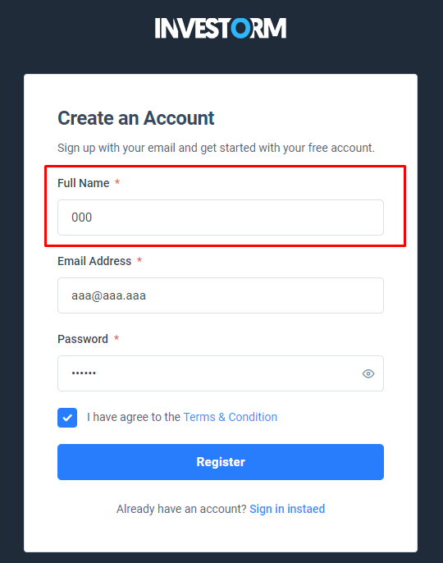

**Expected result:**  Registration will not be completed.

**Issue 2: Accepts only** **Special characters on the Full Name field.**

**Description**

[Steps to Reproduce]

1. Go to URL = https://tariq.wip.websbd.com/

2. Click on Register Button.

3. Type *** in the Full Name text field.

4. Press on Register.

5. Observed that, Registration has been completed.

**Actual Result**: In the Full Name field Accepts only Special Characters.

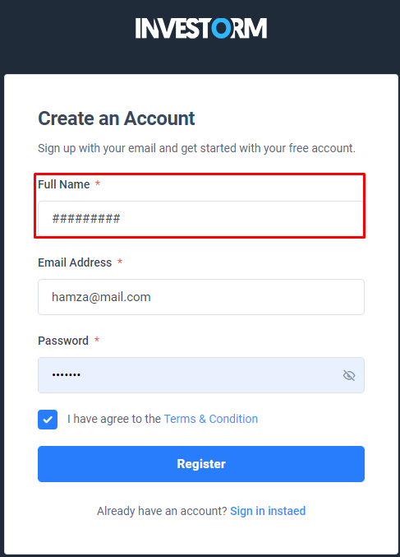

**Expected result:** Registration will not be completed.

**Issue 3: Accepts Numeric value and Special characters on the Full Name field.**

**Description**

[Steps to Reproduce]

1. Go to URL = https://tariq.wip.websbd.com/

2. Click on Register Button.

3. Type 0 * in the Full Name text field.

4. Press on Register.

5. Observed that, Registration has been completed.

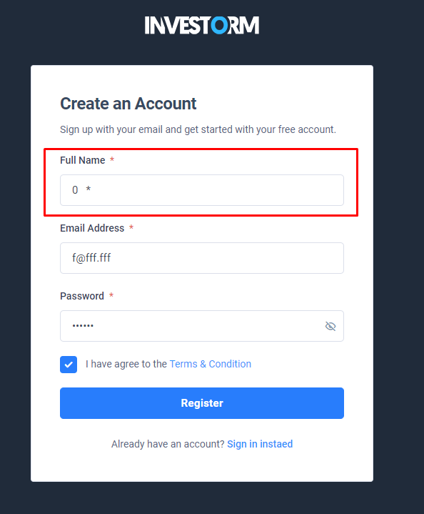**Actual Result**: In the Full Name field Accepts only Special Characters and Numeric Value.

**Expected result:** Registration will not be completed

**Email Address Field**

**Issue 7: Accepts** **Invalid Email** **Domains on Email Address field.**

**Description**

[Steps to Reproduce]

1. Go to URL = https://tariq.wip.websbd.com/

2. Click on Register Button.

3. Type dd@dd.dd in the Full Name text field.

4. Press on Register.

5. Observed that, Registration has been completed.

**Actual Result**: In the Email Address field Accepts Invalid Email.

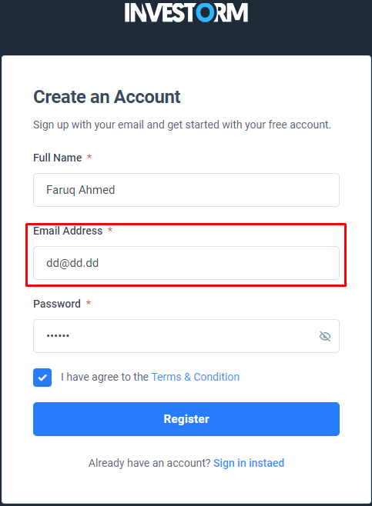

**Expected result:** Registration will not be completed.

**Issue 8: Accepts Invalid Email prefixes on Email Address field.**

**Description**

[Steps to Reproduce]

1. Go to URL = https://tariq.wip.websbd.com/

2. Click on Register Button.

3. Type bb+bb+bb@bb.com in the Full Name text field.

4. Press on Register.

5. Observed that, Registration has been completed.

**Actual Result**: In the Email Address field Accepts Invalid Email.

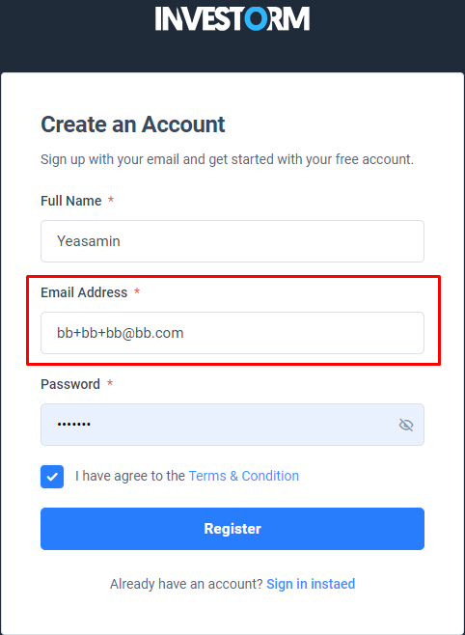

**Expected result:** Registration will not be completed.

**Issue 9: Accepts Invalid Email** **Prefixes on Email Address field.**

**Description**

[Steps to Reproduce]

1. Go to URL = https://tariq.wip.websbd.com/

2. Click on Register Button.

3. Type abcd--@mail.com in the Full Name text field.

4. Press on Register.

5. Observed that, Registration has been completed.

**Actual Result**: In the Email Address field Accepts Invalid Email.

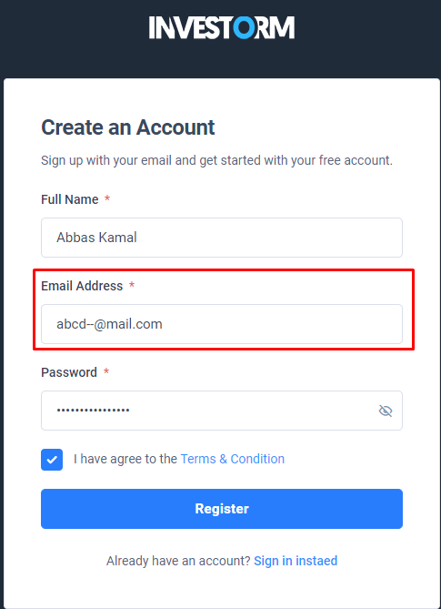

**Expected result:** Registration will not be completed.

**Issue 10: Accepts Invalid Email** **Prefixes and Domain on Email Address field.**

**Description**

[Steps to Reproduce]

1. Go to URL = https://tariq.wip.websbd.com/

2. Click on Register Button.

3. Type ____@qq.qq in the Full Name text field.

4. Press on Register.

5. Observed that, Registration has been completed.

**Actual Result**: In the Email Address field Accepts Invalid Email.

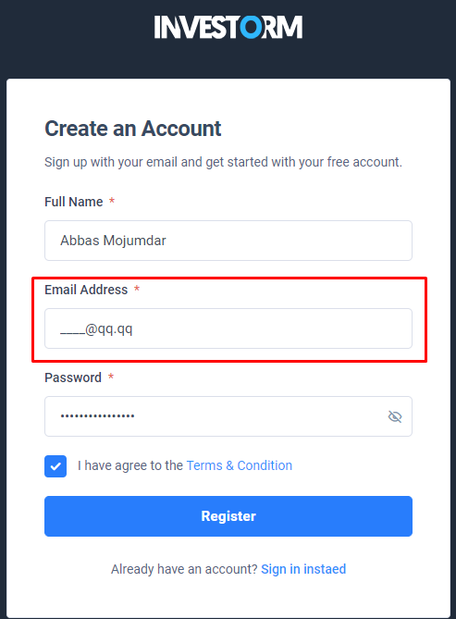

**Expected result:** Registration will not be completed.

**Password Field**

**Issue 11: password eye icon doesn't work.**

**Description**

[Steps to Reproduce]

1. Go to URL = https://tariq.wip.websbd.com/

2. Click on Register Button.

3. Press on Register.

4. Observed that, password eye icon doesn't work.

**Actual Result**: Not working is the password eye symbol.

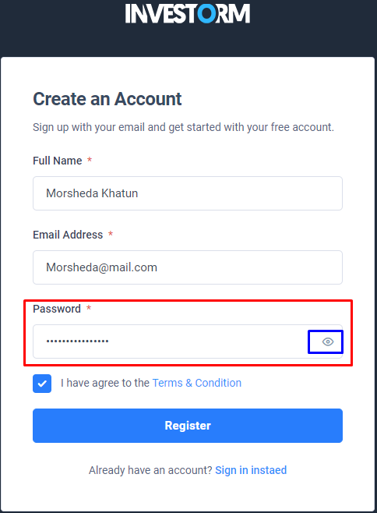

**Expected result:** The password will show when the eye icon is clicked.

**Issue 12: No** **conditions are applied to generate strong passwords.**

**Description**

[Steps to Reproduce]

1. Go to URL = https://tariq.wip.websbd.com/

2. Click on Register Button.

3. Should be suggested strong password.

**Actual Result**: In the password field could not show any strong password format.

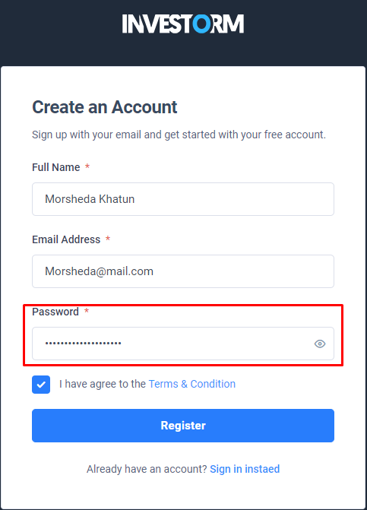

**Expected result:** Conditions are Applied (Use Upper Case Letter, Lower Case Letter, special Character and at least Character)

**Confirmation Message**

**Issue 13: Verification email was not sent to an email inbox.**

**Description**

[Steps to Reproduce]

1. Go to URL = https://tariq.wip.websbd.com/

2. Click on Register Button.

3. Press on Register.

4. Registration has been completed.

5. verification email was not sent to an email inbox.

6. Observed that, Verification email was not sent to an email inbox.

**Actual Result**: Confirmation message was not sent to an email inbox.

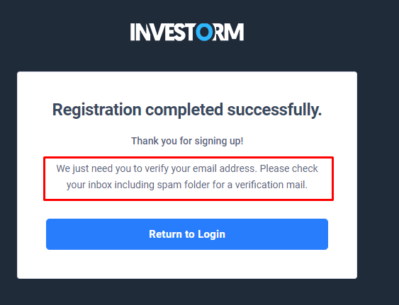

**Expected result:** Verification mail should be sent to an email inbox.

**Reset Password**

**Issue 14: password** **eye icon doesn't work correct way.**

**Description**

[Steps to Reproduce]

1. Go to URL = https://tariq.wip.websbd.com/

2. Click on Register Button.

3. Press on Register.

4. Registration has been completed.

5. verification email was not sent to an email inbox.

6. Enter email address.

7. Click on Forget Code.

8. Enter email address.

9. Check email RESET PASSWORD.

10.Observed that, password eye icon doesn't work correct way.

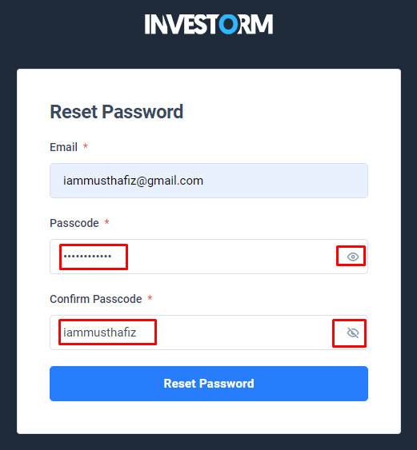**Actual Result**: In the password field eye icon doesn't work correct way.

**Expected result:** When open-eyes icon is clicked the password will show while when closed-eyes icon is clicked the password will not be shown.

**Issue 15: Previously used login password Next reset password is taking the same password.**

**Description**

[Steps to Reproduce]

1. Go to URL = https://tariq.wip.websbd.com/

2. Click on Register Button.

3. Press on Register.

4. Registration has been completed.

5. verification email was not sent to an email inbox.

6. Enter email address.

7. Click on Forget Code.

8. Enter email address.

9. Check email RESET PASSWORD.

**Actual Result**: Taking the same before login password and reset login password.

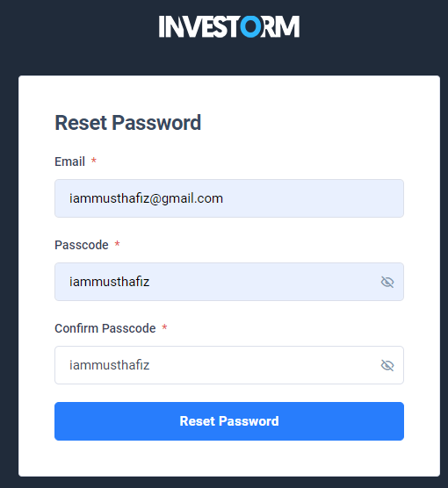

**Expected result**: The login password used earlier should not match the login password used later**.**

**User Profile**

**Issue 16: There is no provision to log in to an account using a username.**

**Description**

[Steps to Reproduce]

1. Go to URL = https://tariq.wip.websbd.com/

2. Click on Register Button.

3. Press on Register.

4. Registration has been completed.

5. Login has been completed.

6. provide rahima123 in Username field.

7. Again login using username.

8. Observed that, Login will not be completed.

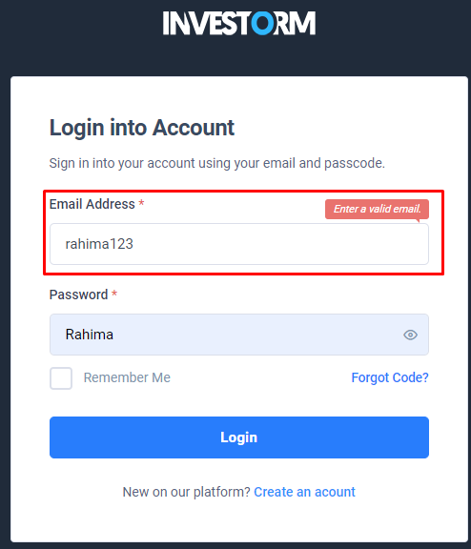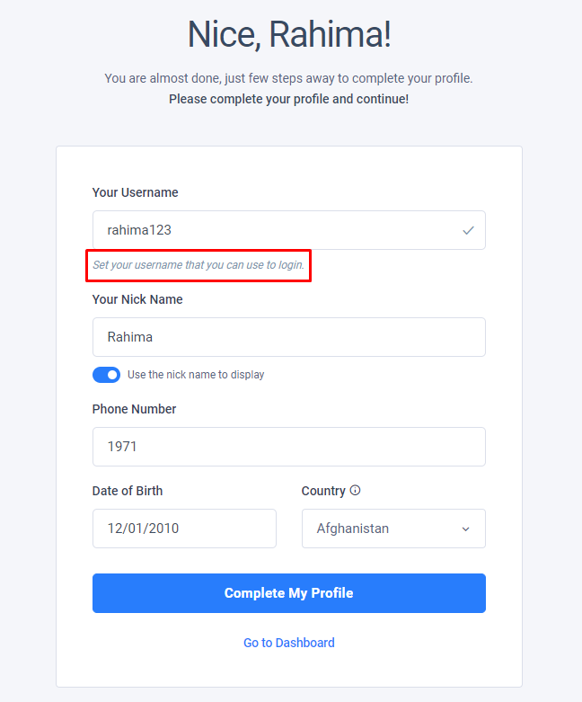**Actual Result**: The usage of a username to log into an account is not permitted.

**Expected result:** Login will be completed.

**Issue 17:** **Nick Name is not showing in the display.**

**Description**

[Steps to Reproduce]

1. Go to URL = https://tariq.wip.websbd.com/

2. Click on Register Button.

3. Press on Register.

4. Registration has been completed.

5. Login has been completed.

6. provide Hafiz in Nick Name field.

7. Click complete My Profile.

8. Observed that, Nick Name is not showing in the display.

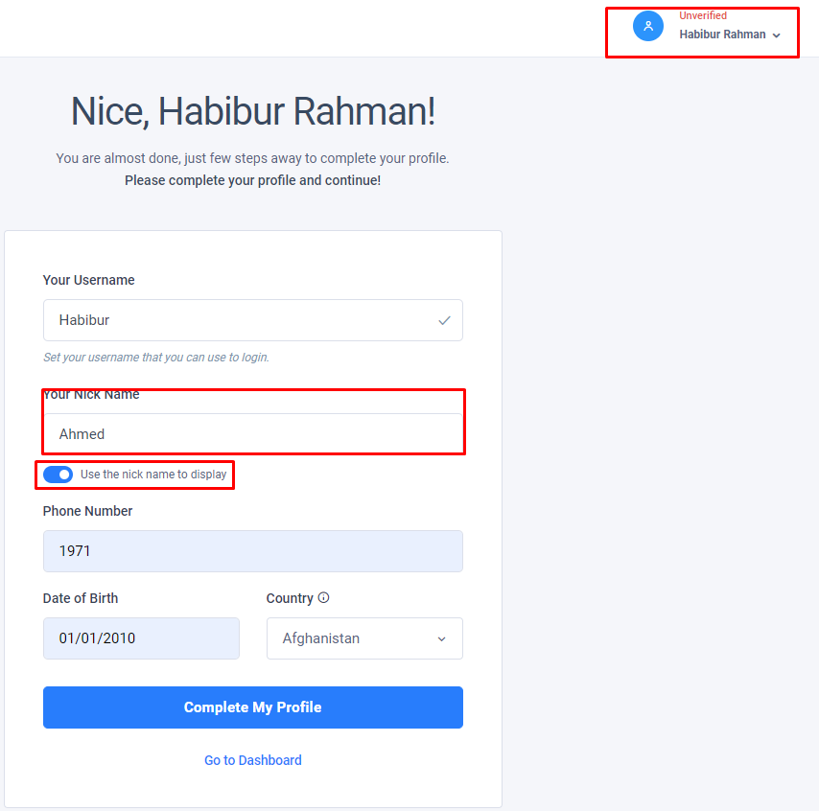**Actual Result**: Nickname does not appear in the display.

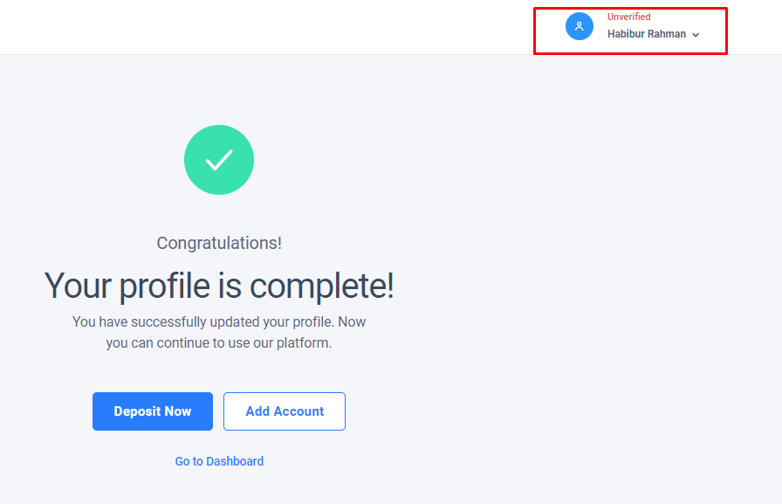

**Expected result:** Nick Name is showing in the display**.**

**Issue 18:** **Phone Number Field accept Alpha Numeric Character.**

**Description**

[Steps to Reproduce]

1. Go to URL = https://tariq.wip.websbd.com/

2. Click on Register Button.

3. Press on Register.

4. Registration has been completed.

5. Login has been completed.

6. provide abc in Phone Number field.

7. Click complete My Profile.

8. Observed that, Phone Number Field accept Alpha Numeric Value.

**Actual Result:** Alphanumeric characters are accepted in the phone number field.

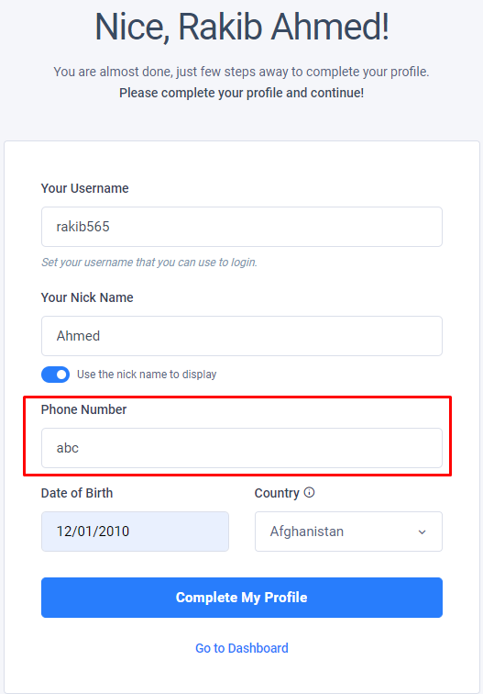

**Expected result:** Does notAcceptAlphanumeric character on this field.

**Issue 19: Phone Number Field Accept** **Invalid Phone Number.**

**Description**

[Steps to Reproduce]

1. Go to URL = https://tariq.wip.websbd.com/

2. Click on Register Button.

3. Press on Register.

4. Registration has been completed.

5. Login has been completed.

6. provide 123456 in Phone Number field.

7. Click complete My Profile.

8. Observed that, Phone Number Field accept Invalid Phone Number.

**Actual Result:** Accept Invalid Phone Number in the Phone Number Field.

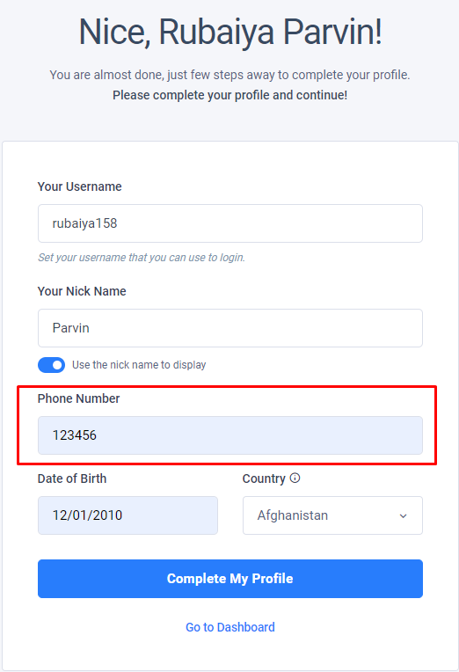

**Expected result:** Does notAcceptInvalid Phone Number on this field.

**Issue 20:** **Phone Number Field** **and Country code is not matching.**

**Description**

[Steps to Reproduce]

1. Go to URL = https://tariq.wip.websbd.com/

2. Click on Register Button.

3. Press on Register.

4. Registration has been completed.

5. Login has been completed.

6. provide +1647-371-0667 in Phone Number field.

7. Click complete My Profile.

8. Observed that, Phone Number Field and Country code is not matching.

**Actual Result:** Country code and Phone Number Field do not match.

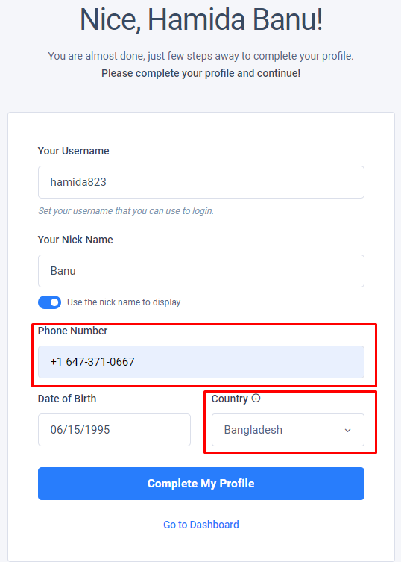

**Expected result:** Must match Phone Number Field and Country code.

**Issue 21: Phone Number Field Accept Invalid Phone Number.**

**Description**

[Steps to Reproduce]

1. Go to URL = https://tariq.wip.websbd.com/

2. Click on Register Button.

3. Press on Register.

4. Registration has been completed.

5. Login has been completed.

6. provide ------ in Phone Number field.

7. Click complete My Profile.

8. Observed that, Phone Number Field and Country code is not matching.

**Actual Result:** Accept Invalid Phone Number in the Phone Number Field.

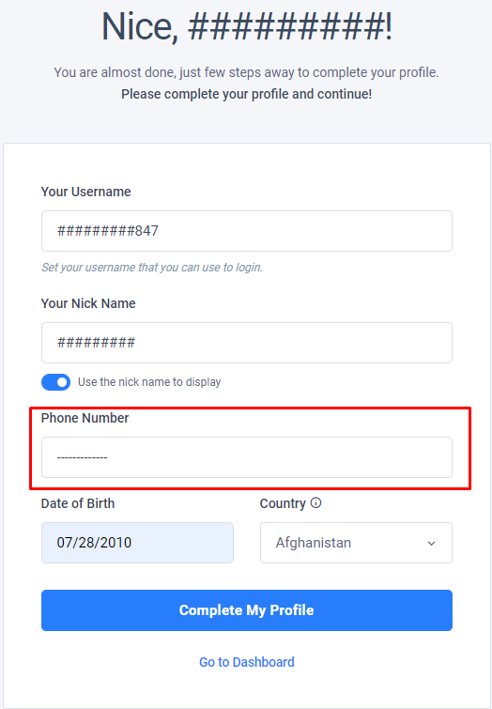

**Expected result:** Must match Phone Number Field and Country code.

**Welcome Page**

**Issue 22: Mobile mode cannot visible all content.**

**Description**

[Steps to Reproduce]

1. Go to URL = https://tariq.wip.websbd.com/

2. Click on Register Button.

3. Press on Register.

4. Registration has been completed.

5. Login has been completed.

6. Click complete My Profile.

7.Go to Welcome page.

**Actual Result:** The web page is not responsive**.**

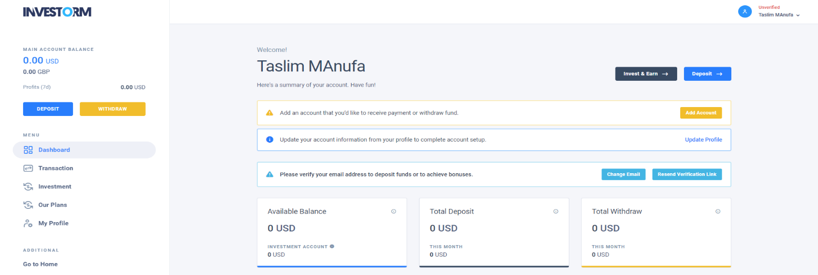

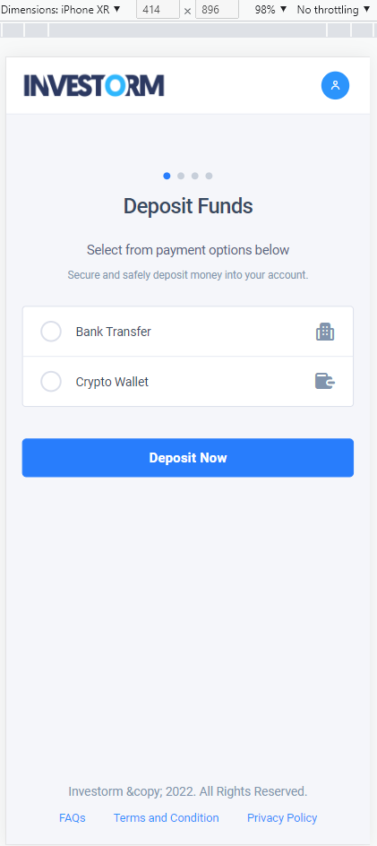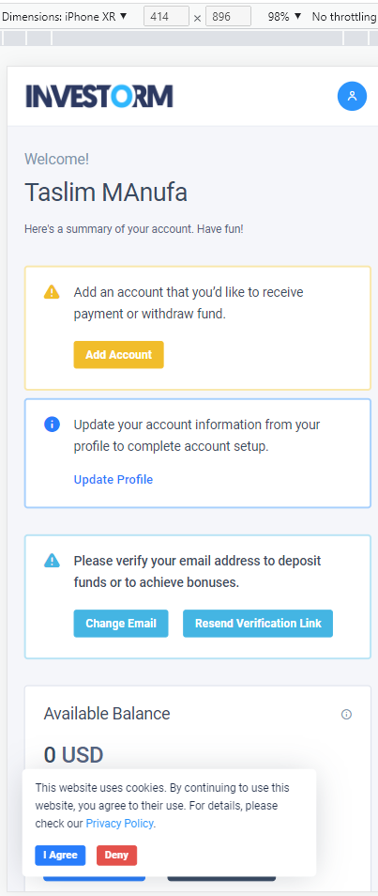

**Expected result:** Needall the content visible mobile mode**.**